Time Logging Middleware
This middleware is used to log slow HTTP requests so you can detect performance problems in your API
- It measures how long each request takes
- If the request is too slow (> 4 seconds), it logs it.
- Create Restaurant.Api/Middlewares/RequestTimeLoggingMiddleware.cs file
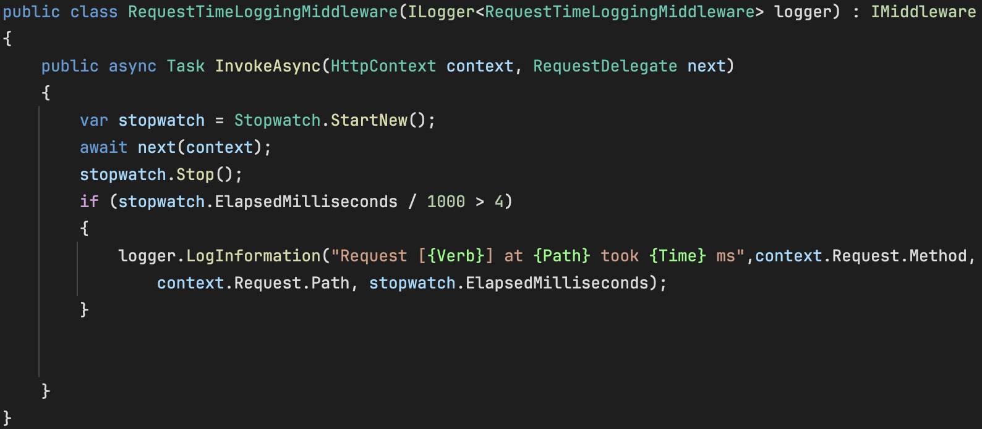
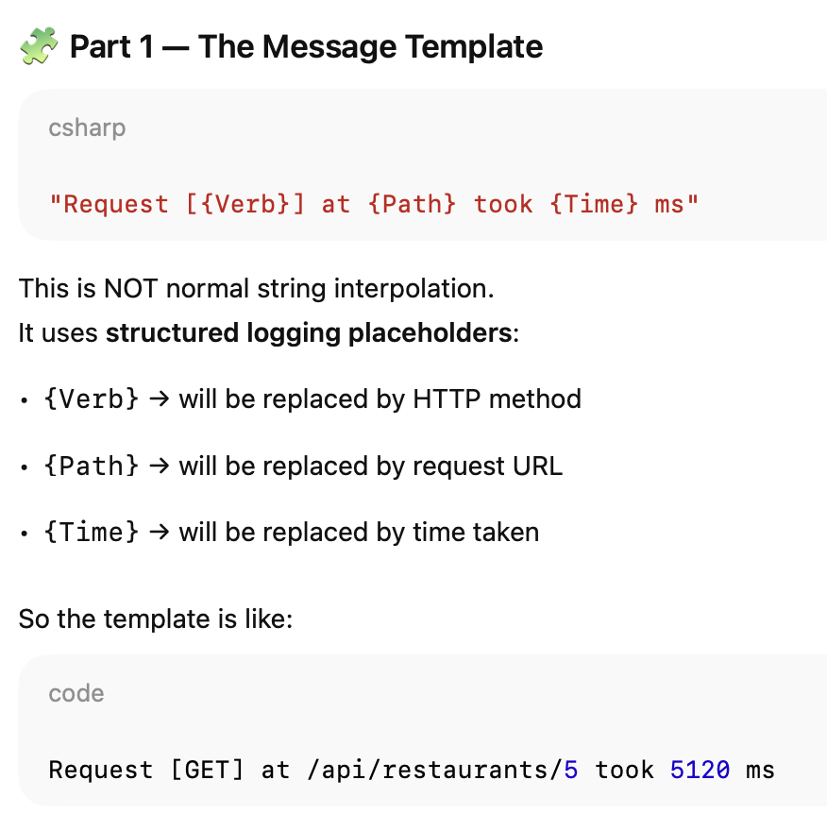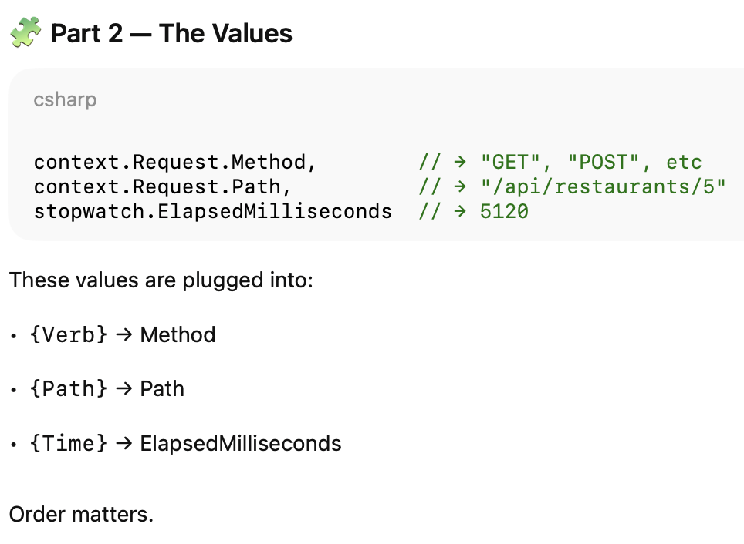

- Register the middleware in the program.cs
- Use the middleware in the program.cs
- Run. But note that if the process request are not more than 4 seconds the message will not appear.
- To test can just put await Task.Delay(5000); in our middleware before await next(context).

